Contents
1. Annual Audit Planning information 2
2. ExAnte Assurance Heatmap 4
3. Organizational (optional) 5
4. Audit Object L2 actualization 5
5. Process based information 5
5.1. L2 AU-109-02-Cyber & IS Strategy and Design 8
5.2. L2 AU-109-08-ICT Incident Management 18
5.3. L2 AU-109-09-Cyber & IS Prevention 22
5.4. L2 AU-109-10-Cyber & IS Detection 34
5.5. L2 AU-109-11-Cyber & IS Control functions (2LoD) 44
5.6. L2 AU-109-12-Threat Intelligence 55

Annual Audit Planning information
Date of last audit and scope period: conducted in Eschborn & Luxembourg from April to August 2024 (sample period 1 January 2023-31 March 2024).
- AU-109-09-Cyber & IS Prevention
- AU-109-10-Cyber & IS Detection
- AU-109-11-Cyber & IS Control functions (2LoD)
Risk Assessment | High
Relevant for LE | DBAG, ExR, EFAG, ECAG, CBF, CH, CBL, CI, CS, LuxCSD, CFCL, ECC and EEX
Changes to RCA | N/A
L2 Additional info | Testing will have a focus on DORA requirements where applicable

 | DBAG | CBF | ECAG | CBL | CFCL | ECC, EEX
IA Judgement | High | High | High | High | High | High
Regulatory required audit frequency | N/A | N/A | N/A | N/A | N/A | N/A
Comment | - | - | - | - | - | -

- AU-109-02-Cyber & IS Strategy and Design
- AU-109-08-ICT Incident Management
- AU-109-12-Threat Intelligence
Risk Assessment | Medium
Relevant for LE | DBAG, ExR, EFAG, ECAG, CBF, CH, CBL, CI, CS, LuxCSD, CFCL, ECC and EEX
Changes to RCA | N/A
L2 Additional info | Testing will have a focus on DORA requirements where applicable

 | DBAG | CBF | ECAG | CBL | CFCL | ECC, EEX
IA Judgement | Medium | Medium | Medium | Medium | Medium | Medium
Regulatory required audit frequency | N/A | N/A | N/A | N/A | N/A | N/A
Comment | 2Y Frequency for AU-109-02 defined by the IA risk assessment | - | - | - | - | -

AU-121-04-CSDR Cyber & Information Security (Cyber & IS)
Risk Assessment | High
Relevant for LE | CBF/CBL/LuxCSD/CS/CI
Changes to RCA | N/A
L2 Additional info | N/A

 | CBF | CBL
IA Judgement | High | High
Regulatory required audit frequency | Yearly | Yearly
Comment | High due to CSDR requirements for CBF and CBL LEs (including LuxCSD and CS). Respective controls, focusing on CSDR systems.

ExAnte Assurance Heatmap
Most recent Ex-Ante Heatmap indication of residual risk (forward looking view): ExAnte Assurance Heatmaps
This report comprises the results of the Q3 2024 Assurance Heatmap ex-post and ex-ante assessments of DBAG, ECAG, CBF, CBL, EFAG, Eurex Repo (ExR), CFCL, EEX and ECC.
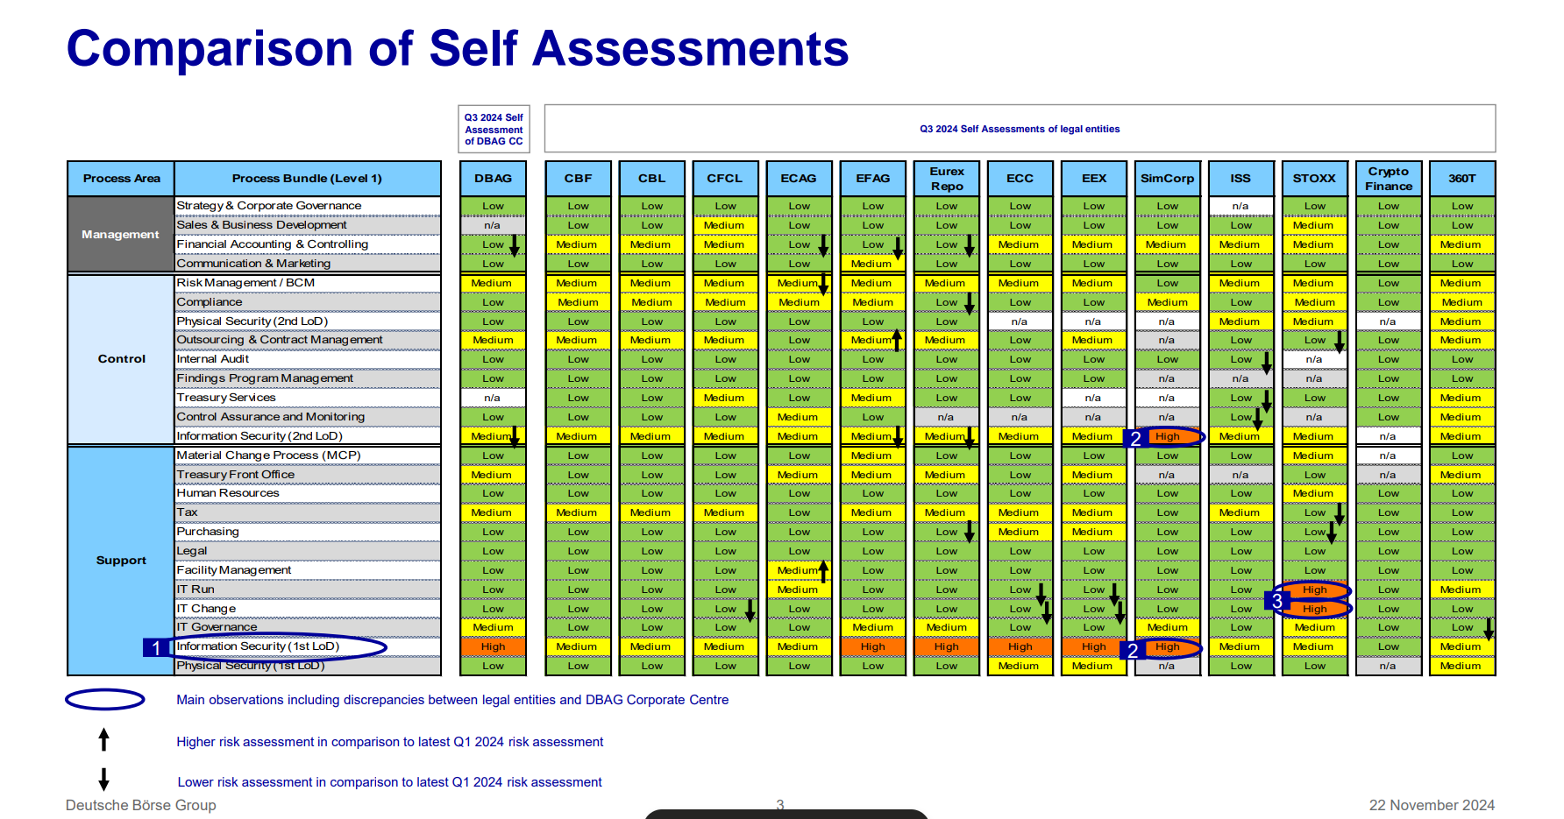
*Note: the results for CFAG, ISS, STOXX, SimCorp and 360T are not relevant for this audit.

Information Security (1LoD) remains the bundle with a majority of High and Medium ratings among the legal entities.
- For DBAG, ‘High’ rating driven by the complexity of the IT infrastructures, in particular the cloud services, security tools and IAM/PAM solutions. Furthermore, because of additional regulatory requirements (e.g. DORA) and internal & external findings (e.g. CSSF), information security needs to stay high on senior management’s priority list. Remediation plans are running (e.g. AMELI, DORA). DBAG rating impacts all other group legal entities.
Information Security (2LoD) remains the bundle with a majority of ‘Medium’ ratings among the in-scope legal entities.

Conclusion: No specific risk identified or to be included in RCA related to this audit object based on the Q3 2024 heatmap reporting.

Organizational (optional)
Major organisational changes in the process owners’ responsibility applied by end of Q1 2024. No re-organizations have occurred since the last audit.

Audit Object L2 actualization
No significant changes in the ICS since the last audit in 2024. No new processes from the ICS not included in this audit.

Process based information
A] As per Master IT application list, 26 IT applications were mapped to the L1’s scoped L2/L3 (Ref.: Sheet 1) for potential coverage in 2025. IA’s preliminary screening reduced the number to 13 applications, as 8 were covered in prior years (2023/24) with no significant findings, at least 2 were removed/decommissioned and 4 were ‘new/in provisioning’ stage. Subject to preparation phase risk-based scoping, IA would decide on specific areas of coverage based on the insights gained during the preparation phase of those 13 applications. i.e. IA would apply a risk-based approach to determine whether and where further testing would be necessary as part of the fieldwork to gain reasonable assurance over the applications.

Application Criticality | 13 IT Applications
Critical | CrowdStrike Falcon Complete (AID2131) | PKI DBAG (AID1064) | PKI MSCA (AID1065) | PKI Clearstream (AID1066)
Major | Splunk Data Analysis Services (AID822) | PA CNAPP (AID2146) | Gpg4Win (AID591) | RPE (AID953)
Minor | Palo Alto Cortex Xpanse (AID2192) | MISP (AID737) | Illusive Networks (AID984)  To be decommissioned by end of May 2025 (link). Conclusion: out of scope | -
Negligible | Cofense Phishing Simulations (AID2091) | OTRS Archive (AID2163) | -
Note: The exact coverage of applications will be captured at the final within the Audit Conclusion.

B] IA is aware that several Group-wide initiatives are ongoing to address known gaps and the associated risks in the area under review, e.g. IT Amelioration program (AMELI), DORA-readiness (Digital Operational Resilience Act - European Union) Program, Hyperion Layer 2 Project, Horizon 2026 and others. The initiatives are supported by regular reporting to management and continue with implementation by end of 2025 / first half of 2026. In particular:
- Many aspects such as Digitalisation of Application Security Document, IS Risk Management, Threat Led Penetration Testing (TLPT), Database Activity Monitoring (DAM), etc. were still undergoing remediation/implementation, especially from AMELI, which is why a further duplicative examination of these aspects will be expedient.
- Additionally, the DORA Readiness Program equally impacted the whole area. Even though the program with the respective segments is tracking and monitoring the implementation progress, it will require further ongoing effort in 2025 to achieve organizational readiness and sustain future BAU activities. Periodic alignment meetings between DBG and regulatory bodies (BaFin and CSSF) are arranged regarding DORA readiness reporting and the plan of remaining activities within the defined timelines.

In this context, SIIs (Self-Identified Issues) that were provided to IA by Group Security department’s (ZZA) were checked for relevance to Group-wide initiatives and accordingly to avoid duplication of efforts, i.e. scope was tailored to exclude topics that were already reported by auditees as deficient.

C] This year, the “L2 AU-109-09-Cyber & IS Prevention” >> “L3 - Nation-State Attack and Cyber Insurance (covering Ransomware Protection)” and the ‘Cyber, Geopolitical and Travel related Threat Intelligence’ processes within the “L2 AU-109-12-Threat Intelligence” are not in scope considering the exhaustive review performed in the prior year and no finding was raised. Also, no indication of insufficient coverage of risks or process change was identified.

However, “L2 AU-109-12-Threat Intelligence” will be covered with a focus on design and operating checks on automation controls applied for various threat feeds from multiple sources regarding arrangements (protection and response) for improved resilience against threats and to check for completeness of the distribution list(s) including legal entity level.

D] “L2 AU-109-09-Cyber & IS Prevention” >> L3: DLP (Data Leakage Prevention)
Considering the SIIs and audit comment from last year, ongoing implementation as planned until October 2025 and the recent incidents on customer data leakage via email, IA plan a separate special audit in Q2 2025 focused on the DLP solution and controls that were designed and implemented.

5.1. L2 AU-109-02-Cyber & IS Strategy and Design
Topic | Review and results
Process description | The 2024 ICT Risk Framework owned by ICT Risk Framework (KJU) Unit - DBG’s Second Line of Defence (2LoD) encompasses a series of documents (policy, guidelines, procedures) to establish comprehensive control requirements in response to Information and Communication Technology (ICT) risks, ensure alignment with applicable regulatory requirements (DORA) and organisational needs.  See below screenshot:  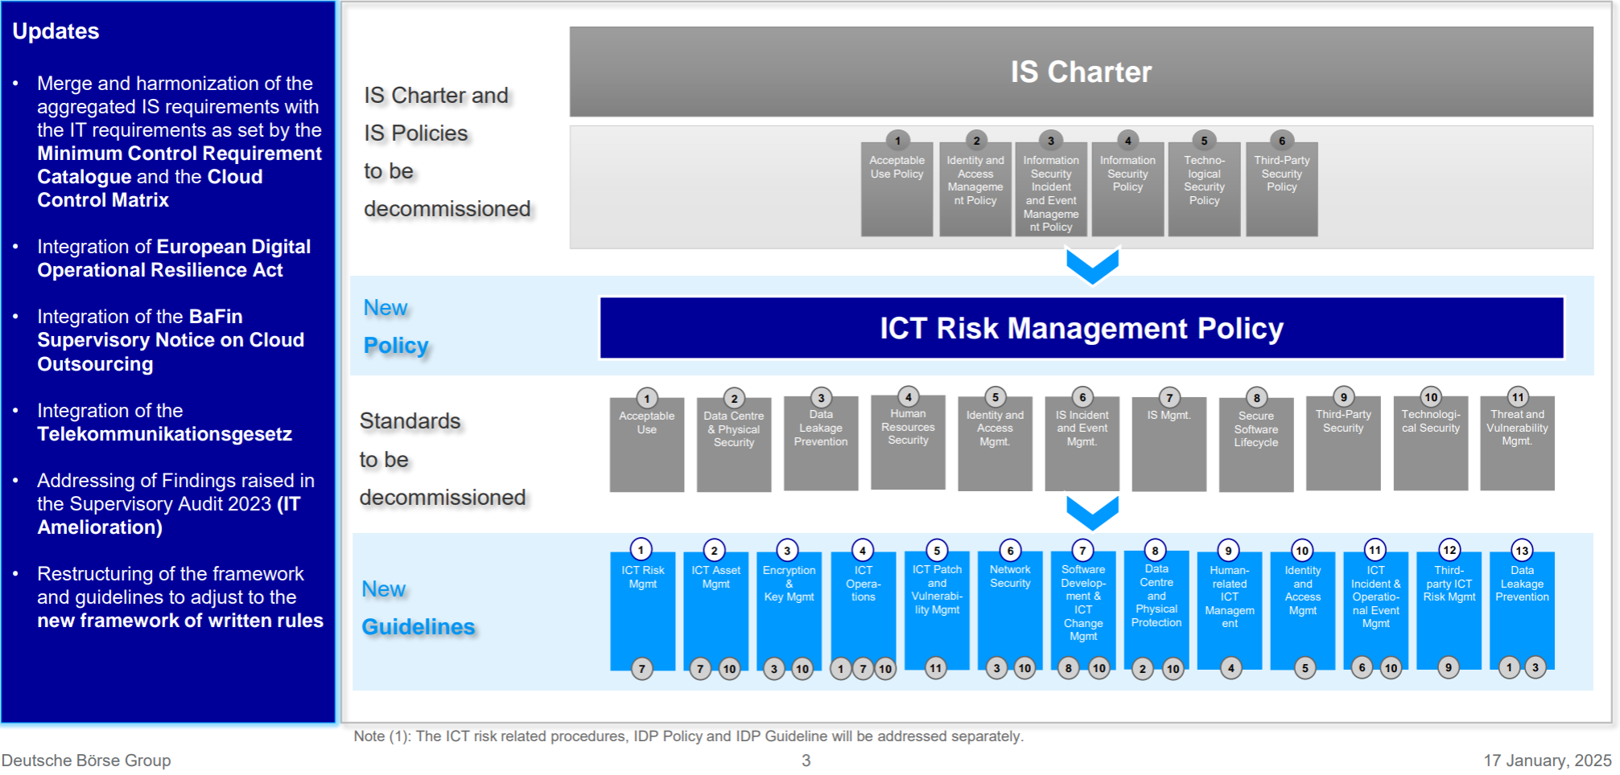  Also, the ICT Risk Management Policy provides the binding ruleset for DBG to manage and oversee ICT risks, with a focus on digital and operational resilience. To add, ICT consolidates both Information Technology (IT) and Information Security (IS).  As per DBG Risk Taxonomy:  - “Information Technology Risk” is the risk of losses resulting from the procurement, use and development of information technology (IT) that has no direct impact on compliance with the protection goals of information security (confidentiality, integrity, availability of information).  - “Information Security Risk” is the risk of losses resulting from the processing of information having a direct impact on compliance with the protection goals of information security (confidentiality, integrity, availability and authenticity of information). It includes cybersecurity risks.  For the “L2 AU-109-02-Cyber & IS Strategy and Design”, IA focus will be on IS risks and topics related to Information Security.  DBAG Digital Operational Resilience (DOR) Strategy (Version 1.0)  The DBAG DOR Strategy, operational since 13 December 2024, aims to provide a comprehensive outline of DBAG's approach to enhancing its digital operational resilience. IA inspected the strategy and noted that it is aligned with DBAG’s business strategy (Horizon 2026) and DBAG Cyber Resilience Strategy. To assess progress, the document stipulates that metrics will be utilized to track the fulfilment of the strategic objectives.  Conclusion for RCA:  Test procedures will be added in the RCA to assess whether the DOR strategy has adequate governance & oversight to ensure the overall objectives and target of the strategy are met. Also, more relevant to the in scope L2 process, IA will verify that the DOR strategy aligns with other relevant frameworks and policies namely the Cyber Resilience Strategy.
Relevant Organizational structure | Refer to Section 3: Organisational related information listed there is applicable here, too.  Conclusion for RCA:  No test procedure to be added.
Key business indicators | As per the DBAG DOR strategy:  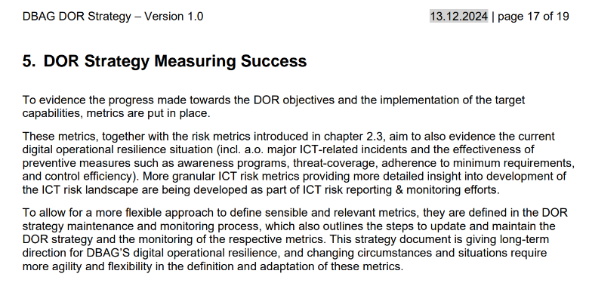  From a risk-based approach and since the DOR strategy is in implementation phase from December 2024, dedicated tests will be defined in the BCA to assess effective review of this strategy via KPI metrics.  Conclusion for RCA:  To be included see -TP5
Relevant legal and regulatory requirements | As part of the evaluation process, IA determined the following external criteria as being generally applicable – when relevant as subsequently amended:  ▪ European Union General Data Protection Regulation (EU GDPR) 2016/679, Art 32  ▪ Central Securities Depositories Regulation (CSD-R) (EU) No 909/2014, 22 Jun 2022, Art.: 45(1); 45(2); 75  ▪ Regulation No 648/2012 of the European Parliament and of the Council with regard to regulatory technical standards on requirements for central counterparties (EMIR RTS 153/2013) with focus on Article 9 “Information technology systems”  ▪ European Securities and Markets Authority (ESMA) RTS Art.: 15(1); 15(2); 53(3); 70(1); 70(2); 70(9); 71(3); 71(4); 75(1); 75(4); 75(5); 75(7); 75(9); 78(1)  ▪ EBA/GL/2019/04 guideline on ICT and Security Risk Management  ▪ EBA/GL/2019/02 revised EBA Guidelines on outsourcing arrangements  ▪ BaFin Circular 06/2024 (Minimum Requirements for Risk Management – MaRisk): AT 4.3 (internal control system), AT 5 (organisational guidelines), AT 6 (documentation), AT 7.2 (technical and organisational resources), AT 7.3 (contingency planning) and AT 9 (outsourcing)  ▪ Supervisory Requirements for IT in Financial Institutions (BAIT) – BaFin Circular 10/2017, updated on 16 Dec 2024 – BaFin – principles 1 (IT strategy), 2 (IT governance), 3 (information risk management), 4 (information security management), 5 (operational information security), 8 (IT operations), 9 (outsourcing and other external procurement of IT services), 10 (IT service continuity management), 12 (critical infrastructure) [Note: At the end of 31 December 2026, the BAIT will be repealed in its entirety - link]  ▪ Digital Operational Resilience Act (DORA) - Regulation (EU) 2022/2554 requires financial entities to improve their digital operational resilience. DORA Chapters – 2(Arts: 5, 6, 7, 8, 9, 10, 13), 3 (Arts:17, 18, 19), 4 (Arts:24, 25, 26, 27), 6 (Art:45) –supported by RTS(s) – ICT RM, TLPT and Major Incidents  ▪ Act of 1 August 2018 on the CNPD, Luxembourg  ▪ Law of 5 April 1993 on the financial sector, Luxembourg  ▪ NIS Directive - (EU) 2016/1148, Luxembourg  ▪ German Data Protection Act: Bundesdatenschutzgesetz (BDSG) vom 30 June 2019  ▪ IT-Sicherheitsgesetz (IT-SiG), Germany  ▪ BSI-Gesetz (BSIG), §8a, Germany  ▪ Telemediengesetz (TMG), §13, Germany  ▪ Protection of Critical Infrastructures – Baseline Protection Concept (KRITIS) – Federal Ministry of the Interior  ▪ CSSF Circular 22/806 on outsourcing arrangements, Luxembourg  ▪ CSSF Circular 17/654 as amended (IT outsourcing relying on a cloud computing infrastructure), Luxembourg  ▪ CSSF Circular 20/750 (Requirements regarding information and communication technology [ICT] and security risk management), Luxembourg  ▪ CSSF Circular 12/552 as amended on Central administration, internal governance and risk management, Luxembourg  ▪ CSSF Circular 24/847 on the ICT incident reporting framework of 5 January 2024, Luxembourg  ▪ Computer Misuse Act (Cap.50A) and the Cybersecurity Act 2018, Singapore  ▪ Personal Data Protection Act 2012 (No. 26 of 2012) (“PDPA”), Singapore  ▪ Internet Banking and Technology Risk Management Guideline, Singapore  ▪ Monetary Authority of Singapore (MAS) Technology Risk Management Guidelines, January 2021  ▪ Information Security Management System (ISMS) Standard: ISO 27001/2:2013 and 2021  Topical Requirements: Issued on 5 February 2025, effective 12 months after, Topical Requirements are a new, mandatory component of the International Professional Practices Framework (IPPF). IA will consider to at least be guided by them in this year’s Cyber audit.
Relevant internal requirements | Applicable internal requirements are:  ICT Risk Framework (Link Here)  Policies - Link to the official DBG Policy Database  - ICT Risk Management Policy, V1.0 valid from 01.01.2025 (Link Here)  Guidelines:  ICT Risk Guidelines - Link to the official DBG Information Security Standards Database  Written Rules Framework Guideline, V1.0 valid from 08.08.2024 (Link Here)  Information Security Organisation Guideline, Level 4, V1.0- last reviewed in 2021 (Link Here)  Others:  Digital Operational Resilience Strategy, V1.0 valid from 13.12.2024 ( Link Here)  Cyber Resilience Strategy, last reviewed in 2025 (Link Here)  Risk Taxonomy January 2025 (Link Here)  Conclusion for RCA:  The listed policies, standards and process documentation cover the key processes in scope of this audit. Versions for policies and standards are the most recent ones. However, assessment of the adequacy with DORA needs to be confirmed during fieldwork. Test procedures are defined accordingly.
IT environment + Cloud services | No application was identified as relevant to this L2 process as per the AAP2025 Golden Source.  Conclusion for RCA:  No test procedure to be added.
Available Risk Management Data | GRM database risk scenarios exported from SAP GRC.  Noted the following relevant scenarios:  ORS_C_FR051 - IS & Cyber Risk  ORS_DBAG_BP012 - Unauthorised software  ORS_DBAG_EP001 - Confidentiality Breach  ORS_DBAG_FR016 - Confidentiality  ORS_DBAG_FR020 - Ransomware  ORS_DBAG_FR021 - Cyber Destruction  ORS_ECAG_FR001 Fraudulent misuse of appl  ORS_EEX_FR006 - Theft of data and fraud  ORS_EEX_FR007 - Int/Ext Sab. on Software  ORS_MDS_016 - Information Security Breach  No risks for further reviews noted from the scenarios.  .  No KRI breaches reported. No claim directly related to the process was opened since last audit.  Based on information available to IA, DBAG CISO area’s ICT Risk Assurance (KIU) conducted reviews on Information Risk Management. None was relevant to this L2.  Conclusion for RCA:  No specific testing planned for fieldwork as no indication of insufficient coverage of risks has been identified.
Data from Compliance | Based on information provided to IA, no relevant information noted in the CCO reports or Compliance control reports applicable to this L2. No information identified specific to this L2 process.  Conclusion for RCA: N/A- No test to be added.
Data from Outsourcing | As per open finding, 2024-063_F01 the new ICT RM TOM is in roll-out through 2025 and so a topic for future audit review. No information identified specific to this L2 process.  Conclusion for RCA: N/A- No test to be added.
Data from Internal Audit | IA to check in this audit SIIs from previous it 2024-040 Cyber and IS audit:  The following 2 SIIs are identified as relevant to this L2:  SII 2024-040_F04: - Outdated IS documentation in Level 4 and Level 5  SII 2024-040_F05: - Cloud Security Guideline overdue annual update and review  Conclusion for RCA: See TP 1 and TP 2
Data from External Audit | No information identified specific to this L2 process.  Conclusion for RCA: N/A- No test to be added.
Relevant Future notes | The following FuN (250312133836) is identified as relevant to this L2 process:  “The new ICT Risk Management Policy (Version: 1.0, Valid from 01.01.2025, prepared by DBAG CICTRO/CISO) and the Digital Operational Resilience Strategy (Version 1.0, 13.12.2024) focus strongly on Risk Management (to manage and mitigate cyber & InfoSec threats) but may be does not support and articulate the Cyber & IS Strategy and Design. Reference to DORA Chapter 2 Article 6 para 2), IA to check if 2LoD (Line of Defence) in its ICT risk management framework included “Cyber & IS Strategy and Design” within strategies, policies, procedures, ICT protocols and tools that are necessary, to ensure that all information assets and ICT assets are adequately protected from risks including damage and unauthorised access or usage. Also, check if “Cyber & IS Strategy and Design” serve the 1LoD functions as a basis for implementing Cyber & IS related processes.”  Conclusion for RCA: To be covered under TP5(a).
Outcome of initiation panel (as applicable) | This sub-chapter is aligned with identified focus points and risks. No specific change as outcome from the initiation panel.  Conclusion for RCA: No dedicated test point to be added.
Conclusion: Risk overview | Key business indicators  Type of risk to be assessed out of this chapter:  B6 Regulatory Risk  B7 Reputational Risk  O1 Regulatory Compliance Risk  O11 Cyber Security Risk  O12 Internal Information Security Risk  O13 Third Party Information Security Risk  The new EU Digital Operational Resilience Act (DORA) is applicable since 17 January 2025. Therefore, tests identified in the RCA will need to take it into account the DORA relevant requirements and compliance.  ESG Impact and Risk for this L2:  Social risk: Failures in cybersecurity leading to data breaches or exposure of sensitive customer information  IT Systems and Cybersecurity: Addressing social risks related to data privacy and cybersecurity.  Assessment:  - Keeping regulation in focus amid change: - Governance is the third aspect of ESG as cyber risks can pose significant governance implications.  - ESG data and reporting need to be accurate: - Cybersecurity is a critical factor in ensuring trustworthy ESG reporting. It works to protect data at its sources while being collected, in transit, and after it has been analysed and reported. In addition, data privacy compliance is also required when personal data is processed in generating ESG reports.  Conclusion for RCA: To be included- See TP3 and TP4
Data Analytics | Based on the current understanding of the mentioned process and provided documentation, the process is not eligible for DA testing.  Conclusion for RCA: N/A- No test to be added.
Defined test | (TP1) IA to check SII 2024-040_F04 status: - Outdated IS documentation in Level 4 and Level 5 (SII from previous audit 2024-040 Cyber and IS audit. à CLOSED as per AMIT tool (AMIT-807).  (TP2) IA to check SII 2024-040_F05 status: - Cloud Security Guideline overdue annual update and review (SII from previous audit 2024-040 Cyber and IS audit).  (TP3) IA to follow up on the “Information Security Organisation Guideline, Level 4, V1.0” (Hint: The guideline was last reviewed in 2021- to assess if it still relevant and why it has not been reviewed /aligned with DORA requirements. (Owner of document: Head of Information Security Framework & Governance))  (TP4) An ICT Risk Management Framework (Version 1.0) is in place since December 2024 which includes the second level documents (the ICT Risk Guidelines) subordinate to the ICT Risk Policy –integrating the IS and IT frameworks into one framework that also incorporates relevant DORA requirements. Areas to be checked:  - Verify the existence of ICT Risk related procedures (Hint: As per the 2024 ICT Risk Framework, ICT risk related procedures will be addressed separately- Have those procedures already been rolled out- unclear at this stage since they are not available on the Intranet?)  - Review sample of written rules (guideline, procedure) relating to IS (E.g. vulnerability management, incident management, change management, ICT Risk Management) to ascertain adherence to regulatory requirements (DORA, CSSF)  (TP5) Framework Alignment, Measurement and Monitoring. Areas to be checked:  - Follow up on FuN: 250312133836  - Confirm that the DOR strategy aligns with other relevant frameworks and policies (Group Risk Framework, CIO/COO IT Strategy, Cyber Resilience Strategy). Check for consistency and cross-references.  - Verify that appropriate metrics are defined and in place to measure the effectiveness of the DOR & Cyber Resilience strategy and implementation initiatives. Check the frequency of reporting and how the results are used for improvement.

5.2. L2 AU-109-08-ICT Incident Management
Topic | Review and results
Process description | Under IT Operation Management, IT Incident Management contributes to restoring normal service operation as soon as possible and minimising the adverse impact on business operations, thus ensuring agreed-upon levels of service quality are maintained. The Problem Management process manages the whole lifespan of all IT problems and ensures that each problem is properly documented and resolved.  IS Incident Management process was covered in Cyber & Information Security audit (2024-040) under the section ““L2 Cyber & Information Security Operations” with no findings identified. (Refer to 2024-040 Cyber and Information Security (DBAG, ECAG, CBF, CBL, CFCL))  Additionally, the ICT Incident Management process had partial coverage in IT Operation Management audit (2025-001) as part of the L2 process 117-05-IT Operations Management. Refer to 2025-001 IT Operation Management (DBAG, ECAG, CBL, CBF, CFCL)  The test was conducted with a limited perspective on the arrangements regarding the timeliness of ICT Incident Reporting according to DORA Arts 17-23.  Through tests, IA inspected and noted that IS Incident Management process follows the DBG group-wide Incident Management framework and templates. IA observed that all the templates related to Incident Management were updated in compliance with DORA, through a specific DORA regulation requirement assessment with no finding. Also, the IA review in 2025-001 IT Operation Management audit revealed no indication of insufficient coverage of risks or process change focused towards Cyber Incident Management. Consequently, no further testing will be done for Cyber Security incidents. Furthermore, during the preparation phase, IA checked with the Head of SOC/CERT (U). He confirmed that there has not been any DORA relevant incident that occurred in the last four months (i.e. since DORA came into effect on 17 January 2025). Also, the Special Audit on DLP (Data Leakage Prevention – Refer section 4D) will have Incident management in scope (IT, operation, data protection).
Relevant Organizational structure | Refer to Section 3: Organisational related information listed there is applicable here, too.  Conclusion for RCA:  No test procedure needs to be added.
Key business indicators | After initial assessment of the L2, there is no direct input for RCA.
Relevant legal and regulatory requirements | Refer to first L2 process: L2 AU-109-02-Cyber & IS Strategy and Design – all legal and relevant regulatory requirements listed there are also applicable here.  For ICT Incident Management: DORA RTS- Major Incidents - Articles 1 to 7 (link)
Relevant internal requirements | After initial assessment of the L2, there is no direct input for RCA.
IT environment + Cloud services | After initial assessment of the L2, there is no direct input for RCA.
Available Risk Management Data | Refer to first L2 process: L2 AU-109-02-Cyber & IS Strategy and Design – all risk management-related data and information listed there is also applicable here.
Data from Compliance | After initial assessment of the L2, there is no direct input for RCA.
Data from Outsourcing | After initial assessment of the L2, there is no direct input for RCA.
Data from Internal Audit | After initial assessment of the L2, there is no direct input for RCA.
Data from External Audit | For open external findings relevant to this process refer to List of Findings.xlsx No. 1 – 6.  IT Amelioration Program - AMELI-1441  Information Security Incidents processing times and handling. JIRA link.  BaFin TD: 30.09.2025  141a, b, c, d, e1, e2, e3 are ECAG (F2)  142a, b, c, d, e1, e2, e3 are CBF (F2)
Relevant Future notes | IA analysed all relevant future notes, mapped them to in-scope processes and included only those relevant to this L2/L3.  FuN: 240715142750  “CERT/SOC team was reviewing at the time of the 2024-040 audit the IS Incident Classification criteria to ensure transparency and consistency, based on BaFin finding. This should be finalized by year end 2024. A new approach and classification matrix will be introduced. Please review once implemented.”  Conclusion: as per data from above section, the BaFin finding remediation is still underway. No action to be included in RCA.
Outcome of initiation panel (as applicable) | The Initiation Panel suggested confirming coverage of this L2 process in previous audits.  Based on the IA agile methodology and risk-based approach and in the light of aforementioned information, IA deemed that there is no risk to be assessed and no test procedures to be carried out in the scope of the 2025-045 Cyber and Information Security audit for this L2. The decision was discussed with the HoIAs at the audit initiation panel (dates 16.04.2025 and 15.05.2025). Refer to minutes of 2025-045 Cyber & Information Security Initiation Panel.
Conclusion: Risk overview | As per GRM risk taxonomy, for relevant details, refer to the first L2 process: L2 AU-109-02-Cyber & IS Strategy and Design  ESG Impact and Risk for this L2:  Social risk: Failures in cybersecurity leading to data breaches or exposure of sensitive customer information  IT Systems and Cybersecurity: Addressing social risks related to data privacy and cybersecurity.  Assessment: Data protection is critical. Protect customer information to foster trust:  Social considerations are also a critical aspect of ESG, and cyber risk can significantly impact, particularly as global cyberattacks and nation-state attacks become more frequent and impactful. Cyberattacks can disrupt critical services. To address these risks, organizations need strong privacy and cybersecurity measures to protect their data. Additionally, they should have robust incident response plans to minimize the impact of a cyberattack on critical services.  Conclusion for RCA:  No test procedure needs to be added.
Data Analytics | After initial assessment of the L2, there is no direct input for RCA.
Defined test | There is no direct input for RCA.

5.3. L2 AU-109-09-Cyber & IS Prevention
Topic | Review and results
Process description | L3: Cryptography and PKI  At DBG, the correct and secure use of cryptography is very important to make sure that the protection goals of the IT-security, laws and regulations are fulfilled. Modern cryptography allows it to keep information nearly fully secret and significantly increases the amount of necessary work for breaking encryption. In order to keep up with the current threats, it is important to change and review the rules of cryptography from time to time.  This audit will focus on including Encryption: key management, outages, certificate management.  - Key management, key requirements and appropriate controls i.e. key length, storage / signing, distribution, validation / recovery, rotation, destruction, hardware security module (HSM), PKI integration with applications/systems, etc. Inspect the process for usage of Google managed keys for cloud-based applications and evaluate if the risks are properly managed i.e. is management accepting the risk of critical data not being protected by own keys.  - post quantum resilience, if applicable and practised. Also, if such resilience has been duly considered to ensure the organisation is prepared for potential attacks on “old” credentials data once technology is readily available.  Certificate Management - Certificate expiry Incident from 3 April 2025 (link): Blue – CIF relevant: No  The incident was caused by an expired Azure secret, which occurred due to insufficient monitoring of secret expiration dates.  Root Cause Analysis performed by: Corporate IT  For RCA: IA to check if certificate expiry is currently monitored and if this incident was limited to a certain area/product/platform? Does DBG have unsecure encryption protocols in use? Encryption at rest should be at least for strictly confidential?  -----  L3: Continuous Threat Detection & Response and L3 Threat and Vulnerability Management:  Advanced Threat Protection (ATP) provides robust security solutions to safeguard DBG against sophisticated cyberattacks and malicious software. Uses the following tools:  - Proofpoint Identity Threat Defense, previously Illusive networks, provides a comprehensive visibility across all identities to prevent identity threats and privilege escalations. Furthermore, Proofpoint Identity Threat and Defense uses modern deception technology to imitate artifacts that appear useful to the attacker for the purpose of detecting lateral movement to critical assets.  - CrowdStrike Falcon Complete is a comprehensive Endpoint Protection and Response (EDR) solution that enhance threat detection and remediation with next-gen antivirus using cloud based artificial intelligence and machine learning. In addition, a Managed Detection and Response (MDR) service delivers 24/7 expert-led monitoring with investigation of every alert and real-time response.  Vulnerability Management at DBG is concerned with the systematic, timely and continuous identification, prioritization, and management of vulnerabilities. While these actions reduce the risk exposure of the business caused by security vulnerabilities in IT assets and manual analysis improves the security posture regarding emergent vulnerabilities and associated risk, the primary purpose of Vulnerability Management is that of a control function.  Specifically, Vulnerability Management has a control function regarding the areas of identification of critical vulnerabilities among others.  In March 2023, the Cyber Defense section (CBD) was entrusted to take over the Threat Intelligence and Threat Hunting processes; with the task to safeguard DBG from cyber and geopolitical threats, thereby ensuring a timely response to incidents and crises. Team comprises colleagues specialized in different aspects of threat intelligence and threat hunting and is responsible for monitoring and comprehending the rapidly changing Cyber and Geopolitical threat landscape.
Relevant Organizational structure | Refer to Section 3: Organisational related information listed there is applicable here, too.  Conclusion for RCA:  No test procedure needs to be added.
Key business indicators | No direct business-related indicators. However certain performance indicators are being reported to Boards.  Example Security report to DBAG AraTech committee:  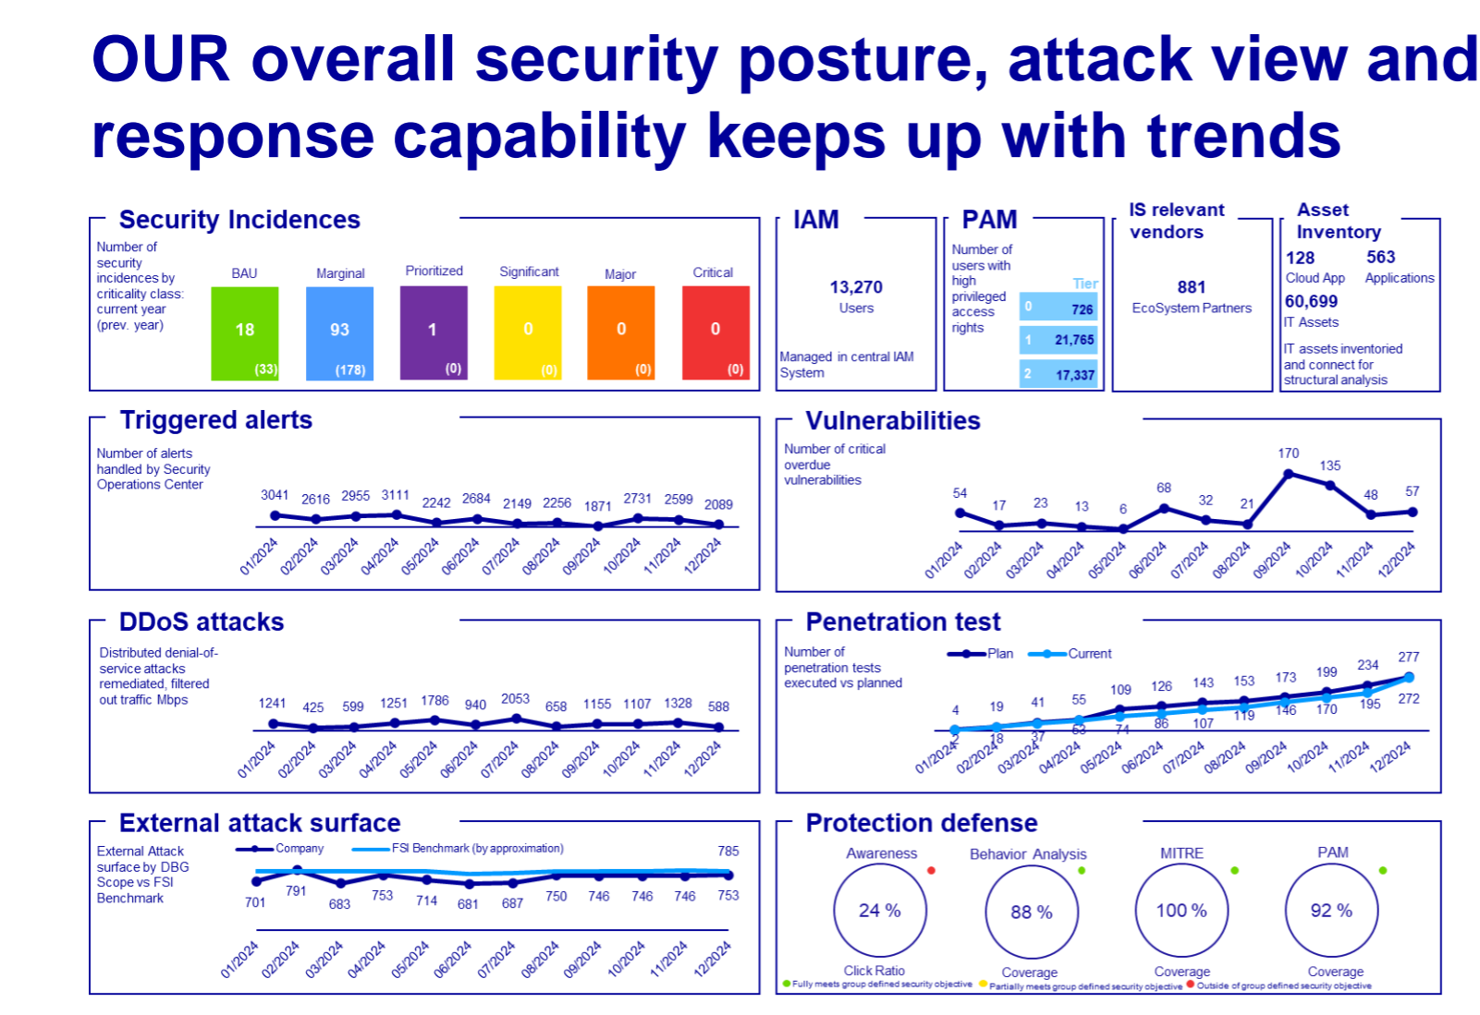  Here, the noted vulnerabilities related to this L2 had an increase during the 2024 attributed to introduction of new tools. These are in our scope (CrowdStrike) below, therefore no need for additional tests.
Relevant legal and regulatory requirements | Refer to first L2 process: L2 AU-109-02-Cyber & IS Strategy and Design – all legal and relevant regulatory requirements listed there are also applicable here.  For Encryption and cryptographic controls, Cryptographic key management: DORA RTS- ICT RM - Articles 6 and 7 (link)  For Vulnerability management– DORA Act L1 Articles 8,13,14,25 and DORA RTS- ICT RM – RTS Articles 10, 23
Relevant internal requirements | Limited to the internal procedures/process description relevant for the L2:  - Encryption and Key Management Guideline, V1.0 valid from 17.01.2025  - ICT Patch and Vulnerability Management v1.0 valid from 17.01.2025  - Anti-Malware Guideline v1.2  - Vulnerability Management Guideline v3.0  - Vulnerability Scan Process, Vulnerability Scan Methodology v 2024
IT environment + Cloud services | Based on preparation meetings and process description in previous rows IA have list of applications in scope for this specific L2. In this chapter IT auditor will perform usual IT assessment for those applications and define the scope of coverage.  L3 Cryptography and PKI àbelow details are from APMS  -----  L3 Continuous Threat & Response and L3 Threat and Vulnerability Management:àbelow details are from APMS
  AID | Application Name | Application Owner | Business Owner | Short Description
  AID1064 | PKI DBAG | Didier Pascal Venier | Nataliia Iskra | The DBAG PKI is an internal “Certificate Authority” dedicated to internal applications and servers. This Certificate Authority is used to digitally sign certificates that are requested by other teams within DBAG. When and if an application needs certificates signed by a globally recognised “Certificate Authority” then an external internationally trusted and recognised “Certificate Authority such as Verisign should be used.
  AID1065 | PKI MSCA | Didier Pascal Venier | Nataliia Iskra | The PKI MSCA is an internal “Certificate Authority” dedicated to internal applications and servers. This Certificate Authority is used to digitally sign certificates that are requested regarding Skype and Outlook S/MIME certificates and Microsoft Windows Hello for Business. Microsoft Windows Enterprise Certification Authority named DBG Windows Hello for Business CA
  AID1066 | PKI Clearstream | Didier Pascal Venier | Nataliia Iskra | PKI Clearstream is an internal “Certificate Authority” dedicated to internal applications and servers. This Certificate Authority is used to digitally sign certificates that are requested by other teams within Clearstream
  AID591 | Gpg4Win | Vojtech Fiurasek | Jeremy Lucas Mendiola | Gpg4win is an email and file encryption package for most versions of Microsoft Windows and Microsoft Outlook, which utilizes the GnuPG framework for symmetric and public-key cryptography, such as data encryption, digital signatures, hash calculations etc.
  AID | Application Name | Application Owner | Short Description
  AID2131 | CrowdStrike Falcon Complete | Michal Rudolf | CrowdStrike Falcon is a security software to monitor endpoints. It enables security processes with EDR and APT functionality.
  AID2146 | PA CNAPP | Jérémy Molinaro | Palo Alto Networks Prisma Cloud is an integrated cloud security platform which is responsible for finding a wide variety of vulnerabilities, misconfigurations, workload threats, and identity and access risks in the cloud environment.
  AID737 | MISP | Zdenek Vaigner | Internal Threat Intelligence Sharing platform
  AID953 | RPE | Piyali Bhaumik | Remote Penetration Test Environment (RPE)
Available Risk Management Data | Refer to first L2 process: L2 AU-109-02-Cyber & IS Strategy and Design – all risk management-related data and information listed there is also applicable here.
Data from Compliance | Based on information provided to IA no relevant information noted in the CCO reports or Compliance control reports applicable to the in scoped L2s/L3s.
Data from Outsourcing | Overview of entities using the IS services and having a service agreement with DBAG including the selected services and KPIs.  Service Selection Overview Info Sec. 1LoD  List of sub-sourcing from DBAG relevant for the above SDSs:  DBAG_IS_Annex1  Auditee also provided a draft of new SDS to be rollout for entities using the central DBAG IS services.  Conclusion for RCA:  In case a new tool / service will be noted in production during the fieldwork for the L3 processes in scope, IA will verify if it has been included in the newly drafted SDS.
Data from Internal Audit | IA to check in this audit an audit comment and SIIs from previous audit 2024-040 Cyber and IS audit:  IA noted that for 5.3 Possibility of data leakage via email, DBG employees can send confidential data outside the internal network via email by deliberately declassifying the attachment/email.  SII 2024-040_F06 status: - Lack of timely update and review of Cryptography Guideline  SII 2024-040_F07: Lack of DLP controls for web upload to non-categorised websites à OPEN with due date in October 2025 is still under implementation. No action required at this stage since SII is tracked by auditee Management.  Conclusion: 2024-040_F06 SII closure to be validated. Test to be included in RCA.
Data from External Audit | For open external findings relevant to this process refer to List of Findings.xlsx No. 7-11.  IDP: JIRA Link  BaFin: 212a,b,c,d,e  Due Date – 31-12-2025
Relevant Future notes | IA analysed all relevant future notes, mapped them to in-scope processes and included only those relevant to this L2/L3.  L3 Cryptography and PKI >>  As per SII 2024-040_F06, Cryptography guideline document in Q3 2024 was replaced by new Data Security Guideline.  FuN: 240708115004  “L3 Cryptography and PKI: From 2024-040 Cyber and IS Audit, following a risk-based approach and supported by agile-testing approach during the audit fieldwork, the Level 3 process “Cryptography and PKI” was outside the scope of the audit. A FuN was raised to include this topic and its test points in the next planned audit (included for this year audit).”  Under L3 Continuous Threat Detection & Response >>  FuN 240410100556  “During the 2024-017 Data Resiliency Audit we have observed that malware protections services are not in production for Microsoft Azure Cloud. Microsoft Defender is activated for sensitive data discovery, but MS launched the new service called "Malware Scanning" for storages and it looks like it has some special capabilities for scanning. It is advised to control the current state of malware scanning for cloud storages in Cyber audit.”  Conclusion: both to be included in RCA
Outcome of initiation panel (as applicable) | This sub-chapter is aligned with identified focus points and risks. No specific change as outcome from the initiation panel.  Conclusion for RCA: No dedicated test point to be added.
Conclusion: Risk overview | As per GRM risk taxonomy, for relevant details, refer to first L2 process: L2 AU-109-02-Cyber & IS Strategy and Design  ESG Impact and Risk for this L2:  Social risk: Failures in cybersecurity leading to data breaches or exposure of sensitive customer information  IT Systems and Cybersecurity: Addressing social risks related to data privacy and cybersecurity.  Assessment:  Cybersecurity is fast becoming the top global risk by impact and likelihood along with climate change and geopolitical conflict. In response, organisations need an efficient model to integrate cybersecurity into their investment decisions.
Data Analytics | Based on the current understanding of the Cyber and IS Prevention process, this L2 may be eligible for DA testing. (This means that structured data may be available, relevant tests can be foreseen and seem feasible.) E.g. testing of coverage of assets in tool rollout. Feasibility to be checked again during fieldwork.
Defined test | For RCA:  Under L3 Cryptography and PKI  (TP1) IA to check SII 2024-040_F06 status: - Lack of timely update and review of Cryptography Guideline (SII from previous audit 2024-040 Cyber and IS audit, Cryptography guideline document in Q3 2024 was replaced by new Data Security Guideline).  (TP2) FuN: 240708115004 (Read in RCA 2.1, 2.2, 2.3) and hint for Certificate Management - (Blue Incident from 3 April 2025 regarding the certificate expiry incident. For expired Azure secret, which occurred due to insufficient monitoring of secret expiration dates. IA to check if certificate expiry is currently monitored and if this was limited to a certain area/product/platform? Does DBG have unsecure encryption protocols in use? Encryption at rest -> should be at least for strictly confidential?)  Note: test point (2.2.j.) regarding “Post quantum cryptography resilience” will be a subject of SPRINT3 (i.e. on the fly and if time permits during fieldwork)  Applications to be covered for L3 Cryptography and PKI:  AID1064 PKI DBAG - as part of testing above  AID1065 PKI MSCA- as part of testing above  AID1066 PKI Clearstream - as part of testing above  AID591 Gpg4Win - as part of testing above  Under L3 Continuous Threat & Response and L3 Threat and Vulnerability Management  Review the Continuous Threat & Response process with the focus on the following topics:  - (TP1) Setup of design of controls for CrowdStrike (monitoring and alerting, coordination, coverage, decommissioning of previous tool)  - (TP2) Setup of detection of advanced persistent threats and relevance to existing processes and tools (SIEM use cases, behavioral analysis)  - (TP3) Review the Vulnerability Management process with the focus on the following topics:  - Setup and design of controls around Rapid 7 applications (e.g. different scanning types, assets covered (cloud), scanning failure management and reporting  - Oversight and reporting of outputs to relevant stakeholders (trend analysis, DSC reporting)  - Management of closure of vulnerabilities in VMT related projects (criteria, timelines, automation, re-scanning)  - (TP4) Based on FuN 240410100556:  Review the usage of Microsoft Defender for malware scanning of cloud related assets  Additionally follow up on Clearstream relevant Malware related incident not noted in the incident list.  - (TP5) Perform General Controls tests related to the L3 Processes Continuous Threat & Response and Threat and Vulnerability Management based on risk-based assessment of applicability.  Applications to be covered for L3 Continuous Threat & Response:  AID2131 CrowdStrike Falcon Complete - as part of testing above  AID2146 PA CNAPP - general IT Controls according risk assessment (TP6)  AID737 MISP - general IT Controls according risk assessment (TP6)  CID3586 of AID551 Microsoft Defender for Endpoint - as part of testing above  Applications to be covered for L3 Threat and Vulnerability Management  AID953 RPE - general IT Controls according to risk assessment (TP6)  AID986 Rapid7 Nexpose - as part of testing above  AID430 VMT & Risk Register

5.4. L2 AU-109-10-Cyber & IS Detection
Topic | Review and results
Process description | The ‘Cyber Detection’ category defines the appropriate activities to detect the occurrence of cyber security events in a timely manner and ensures that their potential impact is understood.  Activities cover:  - Database Activity Monitoring  - Security Information and Event Management (SIEM)  - Advanced Threat Protection (ATP)  Also, the DBAG Cyber Resilience Strategy implemented since April 2025 outlines how the Group intends to identify, mitigate and respond to potential cyberattacks. Refer to Strategic Component 4- Detection (Link Here)  IA examination of this L2 process will have specific focus on the below high-risk areas including DORA-relevant requirements/compliance:  - DORA Regulatory Technical Standards -TLPT (Threat Led Penetration Test)  - Database activity monitoring  - SOC/CERT operations regarding metrics for SOC performance  This is further detailed below:  - DORA Regulatory Technical Standards (RTS) -TLPT (Threat Led Penetration Test)  Inquiries with Rahul Choubey (Head of Vulnerability Management) informed that the drafting and reviewing of TLPT-related framework has been completed. Further, an independent review of TLPT documentation was also exercised in December 2024 by an external consultant (PWC) to achieve TLPT readiness. However, as of date, no TLPT exercise has been performed yet.  Also, IA noted that areas regarding penetration testing, and Advanced Threat Protection (ATP) are already being tracked in the IT Ameli project (see below excerpt under ITSM:2 and ITSM: 4)  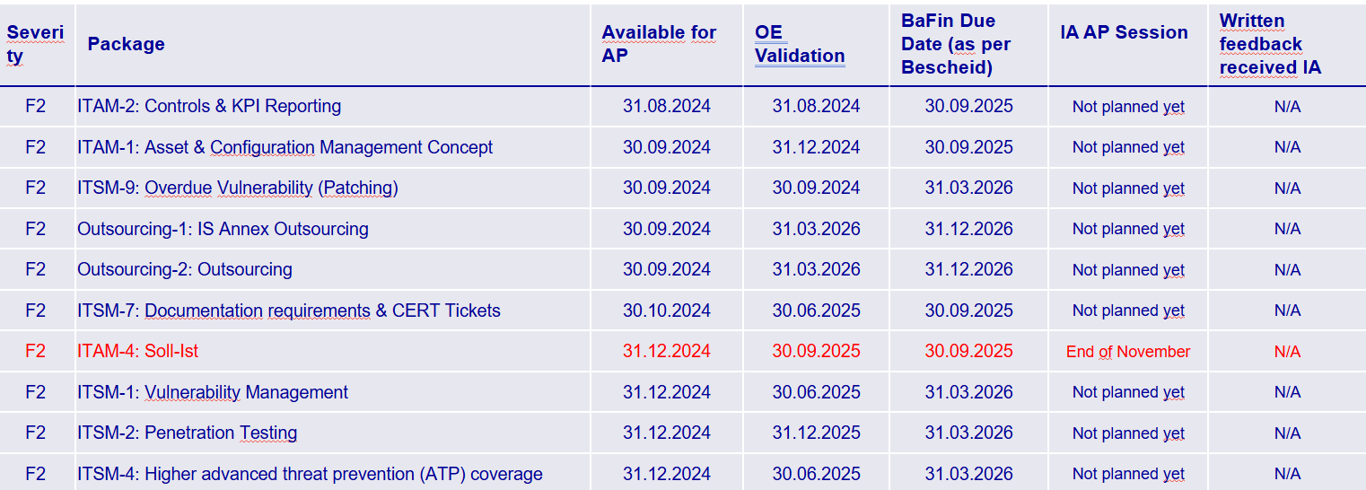  Full details are available here: 20241106_IA_Touchpoint.pptx  SII reported - AMIT-1312: Third Party Software“ and „SaaS“ Application Penetration tests, due on 30 June 2025.  - Database Activity Monitoring (DAM)  A Database Activity Monitoring Procedure (Version 1.0- implemented since 01 January 2025) provides a comprehensive overview of the Database Activity Monitoring (DAM) service, managed by the 1st Line of Defence (1LoD)- Cyber Protection & Automation (S) –Detect & Prevent (U) within DBG.  Also, IA noted that areas over the inadequate monitoring of database servers are already being tracked in the IT Ameli project (see below excerpt under IAM 5- 194/195c- deadline for review is set for June 2026).  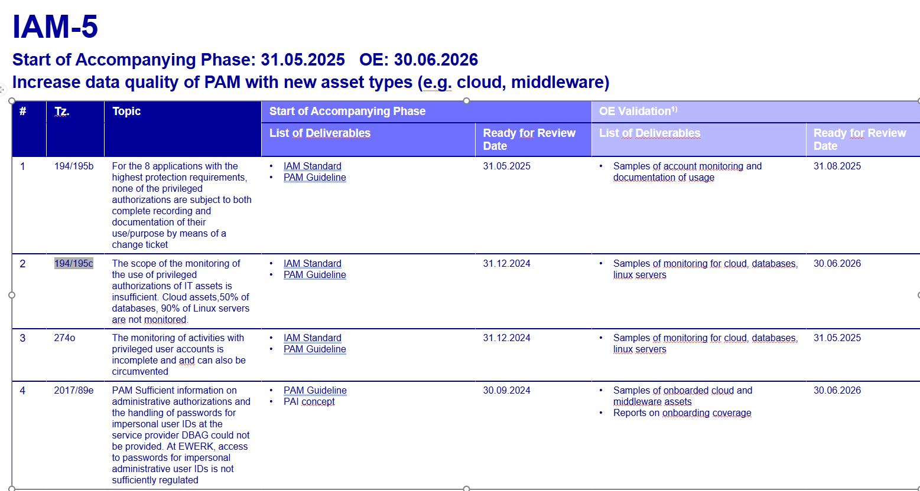  As part of the Preparation phase, IA was provided with potential SIIs impacting the Group security processes (Link Here)- “AMIT-1227  Automation of Manual DB Changes Reporting” was deemed relevant to this area. This will be followed up during the fieldwork.  - SOC/CERT operations regarding metrics for SOC performance especially for detecting attacks at the proper level and coverage of the threat landscape  To evaluate the performance of a Security Operations Center (SOC), metrics are used to ensure effective threat detection and comprehensive coverage of the threat landscape.  IA noted that gaps around the management (collection, storage) of SIEM data are already being tracked in the IT Ameli project. Refer to finding IDs: 133c/134c and 133d/134d. Further, weaknesses noted around KPI reporting on the outsourcing of SIEM processes and measures (e.g. Missing qualitative KPIs, timely processing of potential information security incidents, review of SOC SDSs) are also being followed up in the IT Ameli project. Refer to finding IDs: 141/142b & c and 133k4/134k4.  Conclusion for RCA:  For TLPT: Dedicated test points to be added in the RCA to assess if an action plan has been established to track gaps identified (if any) by external consultant (PwC) during their review of the TLPT framework. Also, IA to check and determine adequate progress regarding AMIT-1312: Third Party Software“ and „SaaS“ Application Penetration tests, due on 30 June 2025. Evaluate the feasibility of timely PT rollout.  For DAM: Dedicated test points to be added in the RCA to review the newly implemented DAM procedure. (Hint: Check for roles and Responsibilities (Imperva, cyber defense, cyber protect teams); how is that holistically managed. Database logs and safeguarding these logs and transfer to Imperva, Splunk). Onboarding to DAM is out of scope since it’s covered by AMELI.  For DAM: To follow up on 2025 SII provided during preparation phase - AMIT-1227: Automation of Manual DB Changes Reporting.
Relevant Organizational structure | Refer to Section 3: Organisational related information listed there is applicable here, too.  Conclusion for RCA: No test procedure needs to be added.
Key business indicators | In the monthly Digital Security Committee (DSC) KPIs relevant to Cyber & Information Security are reported. IA reviewed the January and March 2025 report ( 202501_DSC JF, 202503_DSC_KPI_v2.pdf )and noted that KPIs: Penetration Testing, Malware defense and Audit Log Management for Database Activity Monitoring were in Green.  Conclusion for RCA: No dedicated test step to be added.
Relevant legal and regulatory requirements | Refer to first L2 process: L2 AU-109-02-Cyber & IS Strategy and Design – all legal and relevant regulatory requirements listed there are also applicable here.  For Detection >> TLPT (threat led penetration tests): DORA RTS- TLPT - Articles 2 to 13 (link)
Relevant internal requirements | Refer to first L2 process: L2 AU-109-02-Cyber & IS Strategy and Design – all legal and relevant regulatory requirements listed there are also applicable here.  For Detection >> Database Activity Monitoring Procedure
IT environment + Cloud services | No application was identified as relevant to this L2 process as per the AAP2025 Golden Source.  Conclusion for RCA: No test procedure to be added.
Available Risk Management Data | Refer to first L2 process: L2 AU-109-02-Cyber & IS Strategy and Design – all risk management-related data and information listed there is also applicable here.
Data from Compliance | No information identified specific to this L2 process.  Conclusion for RCA: N/A- No test to be added.
Data from Outsourcing | See FuN 240704080829 below. No other information identified specific to this L2 process.  Conclusion for RCA: N/A- No test to be added as FuN was considered for RCA.
Data from Internal Audit | IA inspected audit comments and SIIs from the previous audit 2024-040 Cyber and IS audit. No information was identified specific to this L2 process.  Conclusion: No additional test procedures will be added to the RCA
Data from External Audit | For open external findings relevant to this process refer to List of Findings.xlsx No. 25 - 29.  Details available here: AMELI Findings Masterfile.xlsx and have been further mapped in the “Process description” area of the in-scope L2 process.  Deficient areas currently being tracked and remediated under the IT Ameli Program will be excluded from the 2025-045 Cyber and IS Audit.  APT and DLP (for EDR solution): JIRA link1, link2  - ECAG 171b  - CBF 172b  Conclusion for RCA: N/A- No test to be added.
Relevant Future notes | FuN: 250320135904  “During the CLLS audit (2025-019), a finding (2025-019_F04) was raised on the inadequate management of vulnerabilities resulting of penetration tests of CLLS applications. Mismatches were found in all three in-scope applications. It would be interesting to perform a test based on data crunching/analytics on the full population in order to understand if this is only an operating effectiveness issue, or it also represents a design level problem.”  FuN: 240704080829  “From 2024-040 Cyber & IS audit - The ex-provider “FortifyData Inc” was responsible to scan DBG systems from the outside and other sources such as Darknet. Overall, it was an integrated cyber risk management & ratings platform for identifying, monitoring and presenting cyber risks. Furthermore, IA was informed the vendor FortifyData will be offboarded and replaced by vendor ‘Palo Alto Cortex Xpanse’ (Palo Alto) to provide a similar web platform for cyber risk management. Palo Alto services differ from FortifyData in the sense that it will also provide benchmarking with the industry and provide scoring based on vulnerabilities in DBG’s internet exposed websites and servers but not have the Risk Register and Risk Assessment as FortifyData did. The scans by Palo Alto will be performed externally and not require any internal information.  According to information provided during preparatory and fielwork meetings, RFP (request for proposal) was completed, outsourcing preassessment and contracts were under review by Legal, Cloud, etc. and Palo Alto shall be onboarded in September 2024. The service by FortifyData Inc. is planned to be decommissioned end of September 2024 and the contract runs until 2 October 2024. For a limited time, services of both vendors shall be used in parallel. Transition period is planned until end of September 2024 followed by access revocation. IA to check the new vendor Palo Alto provided setup and services. (Reference - 2024-040 BCA and Cyber Prevention working paper- TP4)”
Outcome of initiation panel (as applicable) | This sub-chapter is aligned with identified focus points and risks. No specific change as outcome from the initiation panel.  Conclusion for RCA: No dedicated test point to be added.
Conclusion: Risk overview | As per GRM risk taxonomy, for relevant details, refer to first L2 process: L2 AU-109-02-Cyber & IS Strategy and Design  ESG Impact and Risk for this L2:  Social risk: Failures in cybersecurity leading to data breaches or exposure of sensitive customer information  IT Systems and Cybersecurity: Addressing social risks related to data privacy and cybersecurity.  Assessment:  Ransomware attacks are soaring: - Lucrative ransomware attacks continue to increase globally and can quickly cripple an organization’s operations and reputation. Amid the severe consequences, many organizations are tempted to pay the ransom. Unfortunately, ransomware payments only encourage more crime and creates a costly cycle. To combat ransomware attacks, modern cybersecurity measures should be put in place to minimize their social and financial impact.  Conclusion for RCA: No test procedure needs to be added.
Data Analytics | Based on the current understanding of the Cyber and IS Detection process, this L2 would generally be eligible for DA testing. (This means that structured data is available, relevant tests can be foreseen and seem feasible.) For example, within DBG, structured data in the form of security logs could be retrieved from SPLUNK (AID933) tool - DBG’s Security Information and Event Management (SIEM) and analysed to assess whether anomalies/breaches were followed upon.  However, as detailed in the “Process Description” tab, gaps were identified at design level within the in-scope areas. From a risk-based perspective, IA will therefore not perform any test of operating effectiveness. Also, as indicated above, all gaps noted are being tracked and remediated within the Ameli program.  Conclusion: No additional test procedures will be added to the RCA on this area.
Defined test | (TP1) For TLPT: Dedicated test points to be added in the RCA to perform a review of work performed by external consultant (PWC) on TLPT and check if an action plan has been established to track gaps identified (if any). Also, IA to check and determine adequate progress regarding AMIT-1312: Third Party Software“ and „SaaS“ Application Penetration tests, due on 30 June 2025.  (TP2) For DAM: Dedicated test points to be added in the RCA to review the newly implemented DAM procedure. Check for roles and split responsibilities (Imperva, cyber defense, cyber protect teams); how is that holistically managed. Database logs and safeguarding these logs and transfer to Imperva, Splunk. Also, IA to check AMIT-1227: Automation of Manual DB Changes Reporting.  (TP3) FuN: 250320135904  (TP4) FuN: 240704080829

5.5. L2 AU-109-11-Cyber & IS Control functions (2LoD)
Topic | Review and results
Process description | The 2nd Line of Defence (2LoD) is a controlling layer that oversees ICT risk management within DBG as a whole and advises the Management Body. The DBAG 2LoD provides ICT risk management framework and supports its implementation. Furthermore, DBAG 2LoD ensures compliance through conducting regular ICT risk assurance of the 1st LoD (1LoD) activities and ensures monitoring and respective risk reporting. There are additional control functions as part of 2LoD (e.g. IT Compliance, Outsourcing, BCM) who provide input to the ICT risk management framework and ICT risk management activities.  The management of ICT risks in DBG is distributed across the following risk-related functions and implemented on DBAG level as follows:  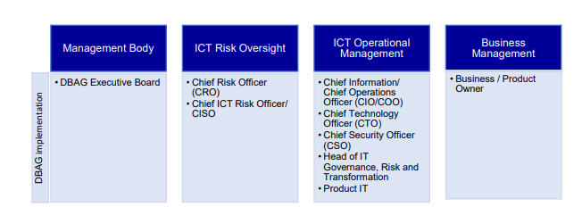  IA noted that the result from 2024-063 Technology Governance Audit, DBG’s 2LoD lacked an IT framework and performed less IS Compliance control activities. Following the 1 January 2024 reorganisation, 2LoD defined a target “IT Compliance & ICT – Operating Model” (TOM) to include the missing activities. By June 2024, it was only aligned with DBAG, ongoing with other Legal Entities (LEs). This finding supported by a detailed CAP (Corrective Action Plan) is still open with six action plans that will be completed by early 2026.
Relevant Organizational structure | The Chief Information Security Office (CISO) is a section of the Chief Risk Officer (CRO) and is the 2LoD function for Information Security in Deutsche Börse AG (link). On 1 January 2025, Christian Gorke assumed the role of Head of Information & Communication Technology (ICT) Risk Officer / Chief Information Security Officer (CISO) – ICTRO/CISO – at Deutsche Börse Group (DBG). (link)  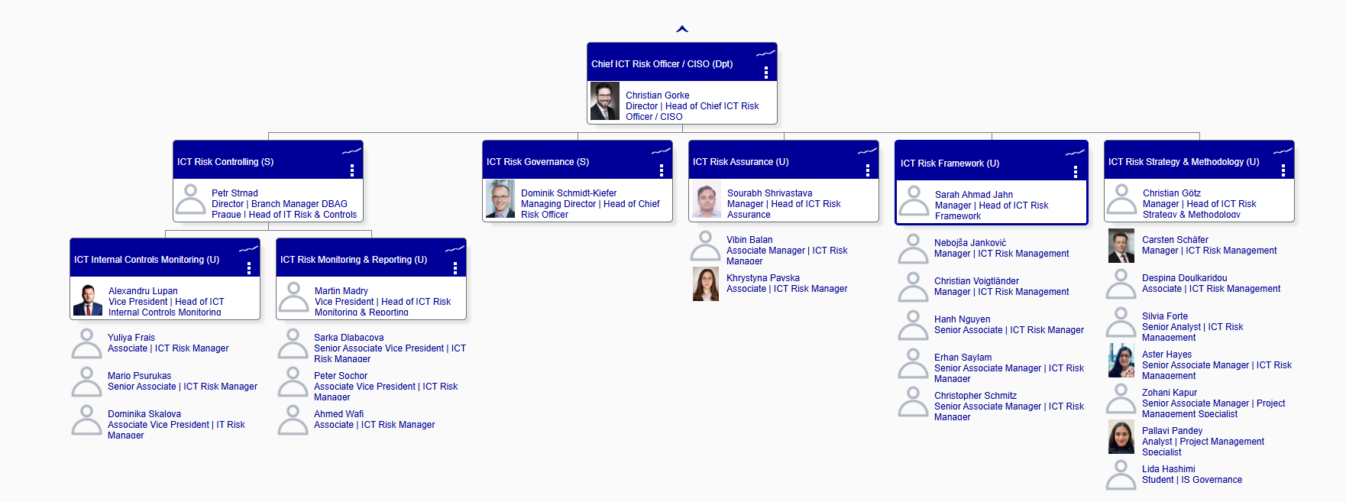  Each DBG Legal Entity (LE) has a Chief Information Security Officer (CISO). LE CISOs are responsible for managing, coordinating, reviewing and monitoring LE cyber and information security, i.e., the protection of its information, LE CISOs are part of the 2nd LoD LE functions.  The below figure is illustrating the ICT risk-related roles and their interfaces within DBAG and exemplary LEs:  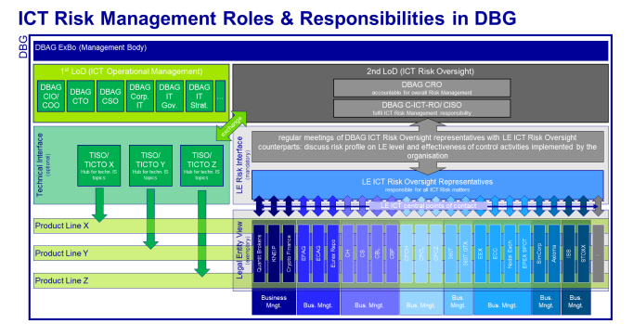  LE CISOs are listed below:  - DBAG: Christian Gorke  - ECAG: Henning Volz  - CBF: Jan Patrick Drehwald  - CBL, CH, CS, CI, LuxCSD: Nejib Zaouali  - CFCL: Karthik Ramamurthy  - ExR: Ulf Wollenweber  - EFAG: Joerg Pfeffer  - ECC, EEX: Marc Schloesser  The Head of Group Compliance of Deutsche Börse AG is the Group Compliance. LE’s Compliance responsible are listed below:  - CBF, CH Compliance: Jan Kobbach  - CBL, CS, CI, LuxCSD Compliance: Christian Heyne  - CFCL Compliance: Sabine Guip  - DBAG Compliance: Marco Popp  - EFAG, ECAG Compliance - Bianca Sahrholz  DBAG ICT Risk Officer: Christian Gorke  Eurex ICT Chief Risk Officer (ICTCRO): Markus Wilke (for ECAG, EFAG and ExR) (link)  Conclusion for RCA: No test procedure to be added.
Key business indicators | Status of Assurance Activities for year 2024 was provided by DBAG ICT Risk Assurance. According to the report all planned assessment activities were completed. (Reports are here). Annual plan 2025 was also provided.  Monthly IT & IS Risk Metrics are here. Almost all metrics are green, safely above the breach thresholds. The following points are noted:  - Starting from June 2024, operational security indicators’ “amber” status turned to “green” by increased number of onboarding endpoints to CrowdStrike.  - Increased number of clicks on the Phishing Simulations emails caused operational security indicator changed to “amber” again starting from September 2024 to February 2025. There is a plan to engage with the worker’s council to discuss positive consequence management, aiming to reward good and correct behavior. Training for those who clicked on spoofed links is planned for implementation in the first half of 2025.  CBF Information Security 2LoD Q2, Q3 and Q4 2024 Reports are here. According to the reports:  - Delays in the DBG-wide finalization of risk assessments. GS is following up with the delays with the asset owners via various meeting formats and individual follow-ups.  - GS is developing new automated solution for “Database manual change control”, delivery expected for Q3 2025 (SII reference: AMIT-1227)  CBL Information Security 2LoD Q2, Q3 and Q4 2024 Reports are here. According to the reports:  - SWIFT 2024 review and attestation resulted in a fully compliant status.  - No incidents above the blue/purple level have been observed.  - Clearstream IS 2LoD assessed the SIEM onboarding process and identified areas for improvement, including outdated documentation and lack of consideration for evolving threats.  - In 2024, IS Assurance services were not fully delivered by DBAG as per the Service description requirements.  ECAG Information Security 2LoD Quarterly 2024 Reports are here. According to the reports:  - SWIFT 2024, successful self-assessment by 2LoD, jointly with CBL, in close collaboration with ECC: in full compliance.  - TARGET2 2024, successful self-assessment by 2LoD: deficiencies due to Information Security related F3 findings, covered by “AMELI”.  - The 2024 control plan for design effectiveness of DBG’s ISMS was completed.  - Due to DORA, service scope refinement of 2LoD SDS Information Security expected for Q4, is changed to Q2 2025.  CFCL Information Security 2LoD Q3 and Q4 2024 Reports are here. According to the reports:  - DORA Gap Analysis (Q1-2024) highlighted 60 gaps to be addressed mostly design related. 80% of the gaps were addressed while 17% will be addressed as part of the Operational & Continuous Improvement phase in 2025. The remaining 3% are related to gaps deemed non-applicable following the release of the DORA final version of the RTSs. No new gaps were identified following the release of the final versions of the RTS/ITS.  - Delays and replanning required for CFCL 2024 IS Assurance plan due to DBAG dependency and capacity shortage. Updating IS assurance plan is ongoing and is covered within open S3 finding 2024-063_F01.  - Unintentional confidential data disclosure incident occurred in October 2024, immediate corrective measures were implemented, relevant regulatory reporting completed. A special audit was planned to be carried out in the 2025 Audit Plan for the DLP issue.  ExR Information Security 2LoD Q3 and Q4 2024 Reports are here. According to the reports:  - Integration of risk landscape delivered by DBAG 2nd LoD InfoSec into ExR InfoSec Board Reporting to be evaluated. Impact of DORA related DBAG activities to be observed.  - SWIFT 2024, successful self-assessment by 2LoD, jointly with CBL, in close collaboration with ECC: in full compliance.  Conclusion: No further tests are planned for this L2, considering open S3/S2 findings from 2024-063 Technology Governance Audit, and ongoing remediations in Ameli Project.
Relevant legal and regulatory requirements | Refer to first L2 process: L2 AU-109-02-Cyber & IS Strategy and Design – all legal and relevant regulatory requirements listed there are also applicable here.
Relevant internal requirements | Refer to first L2 process: L2 AU-109-02-Cyber & IS Strategy and Design – all internal requirements listed there are also applicable here.
IT environment + Cloud services | No application was identified as relevant to this L2 process as per the AAP2025 Golden Source.  Conclusion for RCA: No test procedure to be added.
Available Risk Management Data | Refer to first L2 process: L2 AU-109-02-Cyber & IS Strategy and Design – all risk management-related data and information listed there is also applicable here.
Data from Compliance | Conclusion: No further tests are applicable for this L2, because of open S3/S2 findings from 2024-063 Technology Governance Audit.
Data from Outsourcing | Group Compliance (DBAG) in conjunction with CISO, reflecting on DORA requirements, rolled out a new TOM “IT Compliance and ICT Risk – Operating Model” end of 2024 and operationalised it beginning 2025. Open finding on finalising the outsourcing SDS by DBAG with LEs and completing the 2025 control plan is targeted for Jan 2026.  Conclusion for RCA: Update of service level agreements between LEs and DBAG 2LoD including KPIs review is still under development (addressing S3 finding 2024-063_F01) and targeted for Jan 2026. Therefore, IA will review the relevant controls during the next scheduled regular Cyber and Information Security audit. No test procedure to be added this year.
Data from Internal Audit | IA to check audit comments from previous audit 2024-040 Cyber and IS audit:  5.1 Second (2nd) LoD IS Assurance – IS Assurance planning and activities planned  5.2 Second (2nd) LoD IS Assurance activities CBF  During the preparation phase of this audit, IA noted that:  - for 5.1 updating SDS with DBAG 2LoD including KPIs review still in development (addressing S3 finding 2024-063_F01-A05).  - for 5.2, it will be addressed with the new Post-Trade ICT Risk Assurance Team setup. This audit comment was from an open external finding Tz. 89f/90f (CBF/CH/ECAG) due in June 2026.  Conclusion: No additional test procedures will be added to the RCA because the previous 2024-040 Cyber and IS Audit comments are in development stage.
Data from External Audit | None found.
Relevant Future notes | FuN: 240712141701  “With reference to the closure of the finding 2023-015_F09-A01 Lack of follow-up mechanism and reporting to the relevant LE CISOs for findings raised, Internal Audit noted that a new methodology was put in place to track and monitor non-conformities within the AMIT tool maintained by IT Audit Management team. However, the non-conformities raised by ICT Risk Assurance Team are expected to be uploaded to the AMIT tool only prospectively, i.e., for ongoing and future assessments in 2024 and onwards. At the point of closure of this recommendation, there was no inventory of non-conformities within the AMIT tool. Considering the finding highlighted a design weakness, the operating effectiveness needs to be evaluated and tested in the next instance where IS Assurance process is reviewed.”  Conclusion for FuN: 240712141701 – During 2025-045 Cyber and Information Security audit preparation, IA noted that ICT Risk Assurance team has started using the AMIT tool to monitor their observations. (AMIT, control reports). The FuN can be closed as OK and completed.  FuN: 240923093517  “During the Cyber & IS Audit 2023, IA noted that there was no formal escalation mechanisms put in place to handle unreasonable delays during the process of review and approval of IS Standards. Within the finding 2023-015_F06 Lack of independence of IS Framework and Gov. team in updating IS Standards, it was highlighted that escalations made by the erstwhile Information Security Framework & Governance (ISFG) team to highlight such delays were not leading to a solution or improvement in the process. IA noted that the delays identified were attributed to rejection by Group Security, thereby affecting the independence of ISFG in defining the Information Security requirements within the IS Standards.  During the follow-up of the recommendation, IA noted that a new escalation mechanism was introduced to be applied before the change of methodology:  - ICT Risk Controlling (S) MRI (section under the Chief ICT Risk Officer / CISO (Department)) will either describe the escalation process with the methodology during the next update, or  - (preferred option) Suggest in the new methodology that Group Security will only consult the proposed standards, not approve them.  IA task when reviewing this Fun:  During the next Cyber audit, IA to check if the escalation process is documented in as proposed by the auditee? And if needed, to check for other stakeholders within DBG LEs, which could also block the process like Group Security? Refer to closure documentation of 2023-015_F06-A01”  Conclusion for FuN: 240923093517 – IA observed that new Written Rules Framework Guideline mentions that Guidelines are approved by Managing Director (page 11). IA noted that with this new framework, approval processes cannot be blocked by the other departments such as Group Security or DBG LEs. (evidence). The FuN can be closed as OK and completed.  FuN: 250408110629  “From 2025-031 General Compliance (DBAG, ECAG, CBF, CBL, CFCL) BCA >> 5.5. L2 CCP Compliance >> sub section: Available Risk Management Data. “Related to the L2s/L3s in scope, CPC has one KRI ECAG_COMP_01: Number of new compliance findings. It aggregates the number of new compliance findings, detected during the compliance control checks performed for the previous month. Indicator Relevance: Compliance control checks detect shortcomings in the adherence to applicable regulations and internal policies and procedures; consequently, a breach of the set thresholds would indicate a weakness in compliance that should be addressed and is relevant to the scenario mapped.  There was one breach labelled red:  The controls testing for “IS Risk Management” (ECAG_IT_2023_016) resulted in “not completely appropriate”:  One recommendation with the severity CS3 (material risk),  Two recommendations with the severity CS2 (moderate risk),  One recommendation with the severity CS1 (minor risk) were raised.  The complete remediation is intended until 17 January 2025.”  Conclusion: No further testing has been planned in this audit. IA to review the Compliance Controls testing from 2023 in the upcoming 2025-045 Cyber and Information Security audit >> L2 - Cyber and IS Control functions (2LoD).”  Conclusion for FuN: 250408110629 – IA was informed by ECAG IT Compliance and validated that all open recommendations from ECAG_IT_2023_016 Report have been closed and resolved (evidence).  Conclusion: During preparation, all FuNs related to this L2 have been resolved and there are no additional controls left for the RCA.
Outcome of initiation panel (as applicable) | The Initiation Panel suggested to either limit or to remove detailed coverage over this L2 should the preparation phase not give raise to further audit need.  Following the 2024 Technology Governance audit (2024-063) and its open S3/S2 findings, several key initiatives/remediations are underway. Led by CISO, a new 2LoD target operating model was rolled out by end-2024. Also, IS Assurance launched its updated methodology in October 2024 and is executing the 2025 cycle, with follow-ups due by January 2026. Group Compliance and the CISO also introduced a new IT Compliance and ICT Risk TOM aligned with DORA, now in implementation. An open item remains on finalizing the outsourcing SDS and 2025 control plan, targeted for January 2026. Given these developments, the topic may be deferred for 2026 unless significant risks arise. It is therefore proposed to postpone AU-109-11-Cyber & IS Control functions (2LoD) to next regular C&IS audit.
Conclusion: Risk overview | As per GRM risk taxonomy, for relevant details, refer to first L2 process: L2 AU-109-02-Cyber & IS Strategy and Design  ESG Impact and Risk for this L2:  Social risk: Failures in cybersecurity leading to data breaches or exposure of sensitive customer information  IT Systems and Cybersecurity: Addressing social risks related to data privacy and cybersecurity.  Assessment: Exploring the close connection between Cyber and ESG risks: -  Organisations should have strong governance structures to oversee privacy and cybersecurity risk management and ensure compliance with legal and regulatory requirements. By addressing cyber risks within the context of ESG, organisations can safeguard their operations, customers and reputation while fulfilling their broader social and environmental obligations.  Conclusion for RCA:  No test procedure needs to be added.
Data Analytics | Based on the current understanding of the mentioned process and provided documentation, the process is not eligible for DA testing.  Conclusion for RCA: N/A
Defined test | There is no direct input for RCA.

5.6. L2 AU-109-12-Threat Intelligence
Topic | Review and results
Process description | Threat Intelligence team plays an important role in safeguarding from cyber and geopolitical threats (including Travel Security), thereby ensuring a timely response to incidents and crisis. The team is responsible for monitoring and comprehending the rapidly changing Cyber and Geopolitical threat landscape. Through a collaborative intelligence approach, they collect, analyse data and provide real-time threat indicators across the organization, with the goal of improving Deutsche Börse’s overall security posture. Broadly, the threat intelligence is gathered on following points:  - Cyber Threat Intelligence  - Geopolitical (including Travel Security)  - Physical Threat Intelligence (related to office buildings, postal, emergency services, etc.)
Relevant Organizational structure | Refer to Section 3: Organisational- related data and information listed there are applicable here, too.  To note, Cyber Threat Intelligence and Geopolitical (including Travel Security) Threat Intelligence is under Cyber Defense (CBD), led by Olga Wenge, Head of CBD. These topics will be included for review in this audit.  Alongside, Physical Threat Intelligence (related to office buildings, postal, local blue light and emergency services, etc.) is under Physical Security, led by David Krüger, Head of Physical Security Unit (FSE). The set of tools and procedures are separate from those owned and managed by CBD. The Physical Threat Intelligence topic is outside the scope of this audit and must be covered in the “Physical Security” audits going forward.  Both CBD and FSE join forces on threats that may have an overlapping impact.  Conclusion for RCA: No test procedure to be added.
Key business indicators | Not Applicable. There are no KPI’s defined for collecting and identify information related to Threat Intelligence.
Relevant legal and regulatory requirements | Refer to first L2 process: L2 AU-109-02-Cyber & IS Strategy and Design – all legal and relevant regulatory requirements listed there are also applicable here.
Relevant internal requirements | Refer to first L2 process: L2 AU-109-02-Cyber & IS Strategy and Design – all internal requirements listed there are also applicable here.
IT environment + Cloud services | MISP (AID737) application was identified as relevant to this L2 process as per the preparation phase of this audit. (APMS link)  Conclusion for RCA: No test procedure to be added – covered in TP6 of L3 Threat detection and response.
Available Risk Management Data | Refer to first L2 process: L2 AU-109-02-Cyber & IS Strategy and Design – all risk management-related data and information listed there is also applicable here.
Data from Compliance | No information identified specific to this L2 process.  Conclusion for RCA: N/A- No test to be added.
Data from Outsourcing | No information identified specific to this L2 process.  Conclusion for RCA: N/A- No test to be added.
Data from Internal Audit | We found the following Internal Audit finding to be relevant to this topic from previous Audits - Finding: 2024-056_F05--> OPEN with with due date in December 2025 is still under implementation. Thus, a follow-up on open finding in this audit is not required.  Also, the topics of Cyber Threat and Geopolitical Threat Intelligence were covered as part of 2024-040 Cyber and IS Audit. IA did not find any observations for this topic. As part of the preparation phase for BCA, IA evaluated no significant changes performed around Threat Intelligence for Cyber and Geopolitical tools and processes. So, IA propose to have limited focus with dedicated test points related to automation and Travel Security.  Conclusion for RCA  Finding 2024-056_F05 not included as a test step in RCA as solution is still under implementation.  For Threat Intelligence (Cyber Threat, Geopolitical and Travel) a dedicated test TP3 is created.
Data from External Audit | For external findings relevant to this process refer to List of Findings.xlsx No. 12- 24.  Deficient areas currently being tracked and remediated under the IT Ameli Initiative will be excluded from the 2025-045 Cyber and IS Audit. We analysed the following open External Audit findings to be relevant to this topic:  ECC 215a and 194  CBL LAM 03  Conclusion for RCA: N/A- No test to be added.
Relevant Future notes | FuN: 240722110510  “In the next audit for topic Threat Intelligence, please review how information about Threat Intelligence (also e.g., including information about physical security or travel management) is collected and how it is combined / processed for reporting. Please specifically focus on a review of:  - Sources used for Threat Intelligence data and information and how these sources are processed and combined for the reporting.  - Completeness of the distribution list(s) regarding the relevant recipients including legal entity level to ensure necessary awareness about Threat Intelligence within DBG.  A key document for reporting and its distribution to be considered is the monthly Cyber & Geopolitical Threat Intelligence Report by Group Security – Cyber Defense.”  FuN: 240913151535  “During the 2024-056 Physical Security Audit, the Process Handbook for Intelligence Service has been checked. It was noted that even though the process has been transferred to Cyber Defense in March 2023, the document owner as of the latest update in December 2023 is still shown to be David Krüger from Physical Security. Furthermore, the descriptions in the Handbook don’t clearly indicate that the process is not under Physical Security anymore since some chapters are still mentioning Physical Security being in charge conducting some tasks. However, both David Krüger (from Physical Security) and Jonas Luedke (from Threat Intelligence) confirmed that the process wholly lies with Threat Intelligence. IA therefore advised Jonas Luedke to update the Handbook accordingly.  To Do: IA to check that the Handbook has been updated (regarding owner and clear allocation of responsibilities).”  FuN: 220826135313  “Source: preparation of New York Rep Office audit (2022-053): Article re Cyber security risk: Cyber risk remains elevated as recent geopolitical tensions have further increased cyber risks and highlighted the importance of heightened threat monitoring, greater public-private sector information sharing, and safeguarding against disruptive attacks targeting the financial sector. Given increased operational risks, including risks from geopolitical threats, the Cybersecurity and Infrastructure Security Agency (CISA) published a “Shields-Up” web page (https://cisa.gov/shields-up) to promote awareness of current cybersecurity threats and mitigations. See OCC report linked in FuN Tool. [Hint: IA to check if TP3 is covered under the test points TP1 and TP2]”  Conclusion for FuN: 220826135313 – During the preparation phase of this audit, walkthrough meeting with Cyber Defense revealed heightened threat monitoring, alerting and actions on Cyber, Geopolitical and Travel Security risks. Threat intelligence feeds are data sources used to identify cyber threats looking to take advantage of valuable DBG information and resources. Threat intelligence is managed on the Threat Intelligence Platform (currently MISP – AID737). Threat intelligence data is received from the various threat intel feeds and are made available via the MISP Platform to SIEM Platform for the usage within SIEM use cases. Examples of information sources that are used for the SIEM monitoring and are currently onboarded in the SIEM Platform are:  • Threat intelligence feed from Cyber Information and Intelligence Sharing Initiative (CIISI-EU)  • Financial Services Information Sharing and Analysis Centre (FS-ISAC)  • Threat intelligence feed from Crowdstrike  • Generic Threat Landscape reports from SecAlliance (GTL)  More details were made available as also observed during last Cyber & IS audit (2024-040). Refer WP TP#3 here. No further action to be taken for this FuN. It is considered as OK and completed.  Overall Conclusion: 2 FuNs to be included in RCA
Outcome of initiation panel (as applicable) | The Initiation Panel suggested to limit the coverage over “L3 Cyber and Geopolitical Threat Intelligence” if there were no significant changes in the process of Threat Intelligence for these topics. Previous year audit outcome yielded no observations on this L2.  However, “L2 AU-109-12-Threat Intelligence” will be covered in this audit, with a specific focus on automation controls applied for various threat feeds from multiple sources regarding arrangements (protection and response) for improved resilience against threats. Also, check for completeness of the distribution list(s) including legal entity level.
Conclusion: Risk overview | As per GRM risk taxonomy, for relevant details, refer to first L2 process: L2 AU-109-02-Cyber & IS Strategy and Design  ESG Impact and Risk for this L2:  Social risk: Failures in cybersecurity leading to data breaches or exposure of sensitive customer information  IT Systems and Cybersecurity: Addressing social risks related to data privacy and cybersecurity.  Assessment:  Cybersecurity is emerging as a major ESG factor, with strong alignment to financial and investment risk, growing regulatory scrutiny, and real-world impact:< - From a broader societal perspective, inadequate protections in cyberspace can lead to macro-economic damages with national strategic implications, industrial espionage, the erosion of incentives for innovation and investment, and the violation of data privacy. They also include threats to the critical functions that underpin economic and national security, the safety and freedom of citizens. Organisations are increasingly aware that the risks from Cybersecurity are not limited to one directly affected but also extend to the entire society that underpins the economy and market valuations.  Conclusion for RCA: No test procedure needs to be added.
Data Analytics | Based on the current understanding of Threat Intelligence, the process is not eligible for DA Testing beyond simple analysis of evidence obtained as Excel lists during the audit.
Defined test | Input for RCA.  (TP1) FuN: 240722110510 – (note: refer TP5 of L2 Cyber & IS Detection). Also, IA to check for completeness of the distribution list(s) including legal entity level.  (TP2) FuN: 240913151535  (TP3) “L2 AU-109-12-Threat Intelligence” may be covered to a limited extent, pertaining to DE and OE checks on automation controls applied for various threat feeds from multiple sources regarding arrangements (protection and response) for improved resilience against threats.  Application to be covered:  AID737 MISP - as part of testing above (refer TP6 of L3 Continuous Threat & Response)

